Phase 1 – Application Specifications

Product Capabilities

LockedMe.com is an application designed to allow users to create, read, update, and delete user-specified files through an intuitive user interface. The first prototype will allow any user to:

* Retrieve a list of file names in an ascending order
* Add a new user specified file
* Delete a user specified file
* Search a user specified file

Appearance

The prototype of the application will display a menu of all its operations through the console, as well as allow user to interact with it via a command line console.

User Interactions

LockedMe.com will operate through a command line console through the following instructions:

1. Enter (1) to retrieve the list of files, sorted by file names
2. Enter (2) to Create, Update, Delete, and Read file names
3. Enter (C) to Create a text file
4. Enter (R) to Read a text file
5. Enter (U) to Update a text file
6. Enter (D) to Delete a text file
7. Enter (S) to Search a text file
8. Enter (E) to Exit submenu
9. Enter (3) to close the application

Backlog

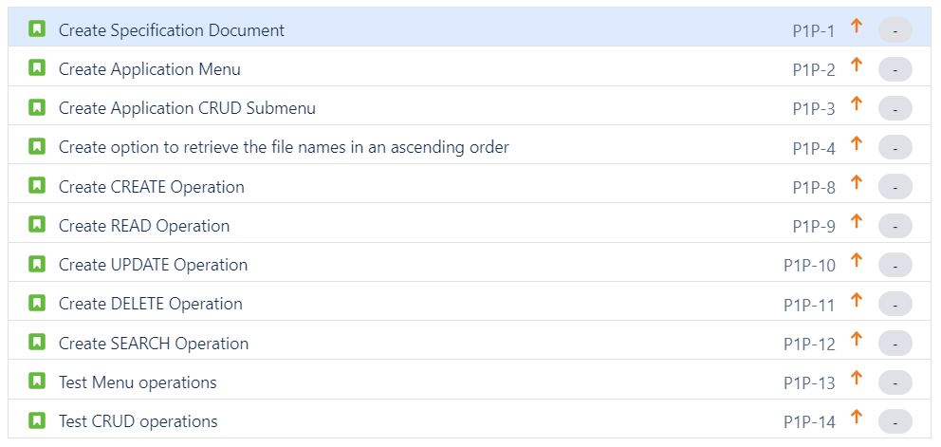

Sprint 1

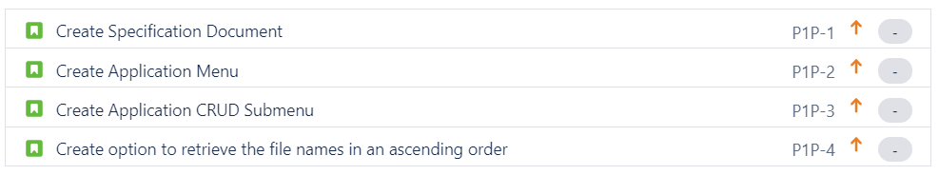

Sprint 2

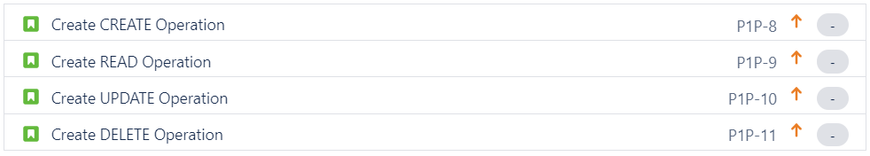

Sprint 3

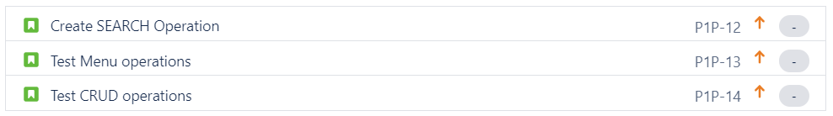

Java Concepts

The implementation of LockedMe.com required the following Java concepts:

* Utilization of java.util.Scanner for capturing user input
* Utilization of System.getProperty for defining project folder paths
* Utilization of control blocks (loop) such as “FOR” and “WHILE” for menu operations
* Utilization of conditional blocks such as “IF” and “SWITCH” for menu operations
* Utilization of OOPS objects such as classes and encapsulation to separate main flow from directory operations
* Utilization of File Handling for CRUD operations
* Utilization of Try/Catch blocks for exception handling
* Utilization of collections for managing list of files in directory
* Data structures – ArrayList to manage directory files
* Sorting Technique – Implementation of Collection.sort(), which uses MergeSort for sorting objects

Flow Chart

